Conference Paper Title
Author Name^{1,*}, Author Name^{1,2}
¹Department, University/Organization, City, Country
²Department, University/Organization, City, Country
Abstract:This electronic document is a template for papers submitted to the conference. Please follow these instructions to edit your paper before submitting.
Keywords:Keyword One, Keyword Two,Keyword Three

1. Introduction
This template includes specific instructions for the papers submitted to the conference. This template has been tailored for output on the A4 paper size.The papers should be in MS Word 2003/2007/2010.
2. Main Body
2.1.Paper
The paper should be written in English.The paper should be composed of title, author(s), abstract, keywords, introduction, main body, conclusions, and references. The paper submitted to the conference should be 6-18 pages.
2.2.Title
The title should be no more than 25 words. The title should not include punctuation in the end, such as the point or question mark.
2.2.1. Abstract
The abstract is a brief introduction of the paper. It should include 40-400 words with no formulas, pictures, tables, superscripts or subscripts.
2.2.2. Keywords
There should be 3-8 keywords in the paper. The keywords should be separated by commas.
3. Details
3.1.Figure
The figures should be clear and they should be numbered as Figure 1, Figure 2, Figure 3 etc. There should be annotations behind each figure as following:
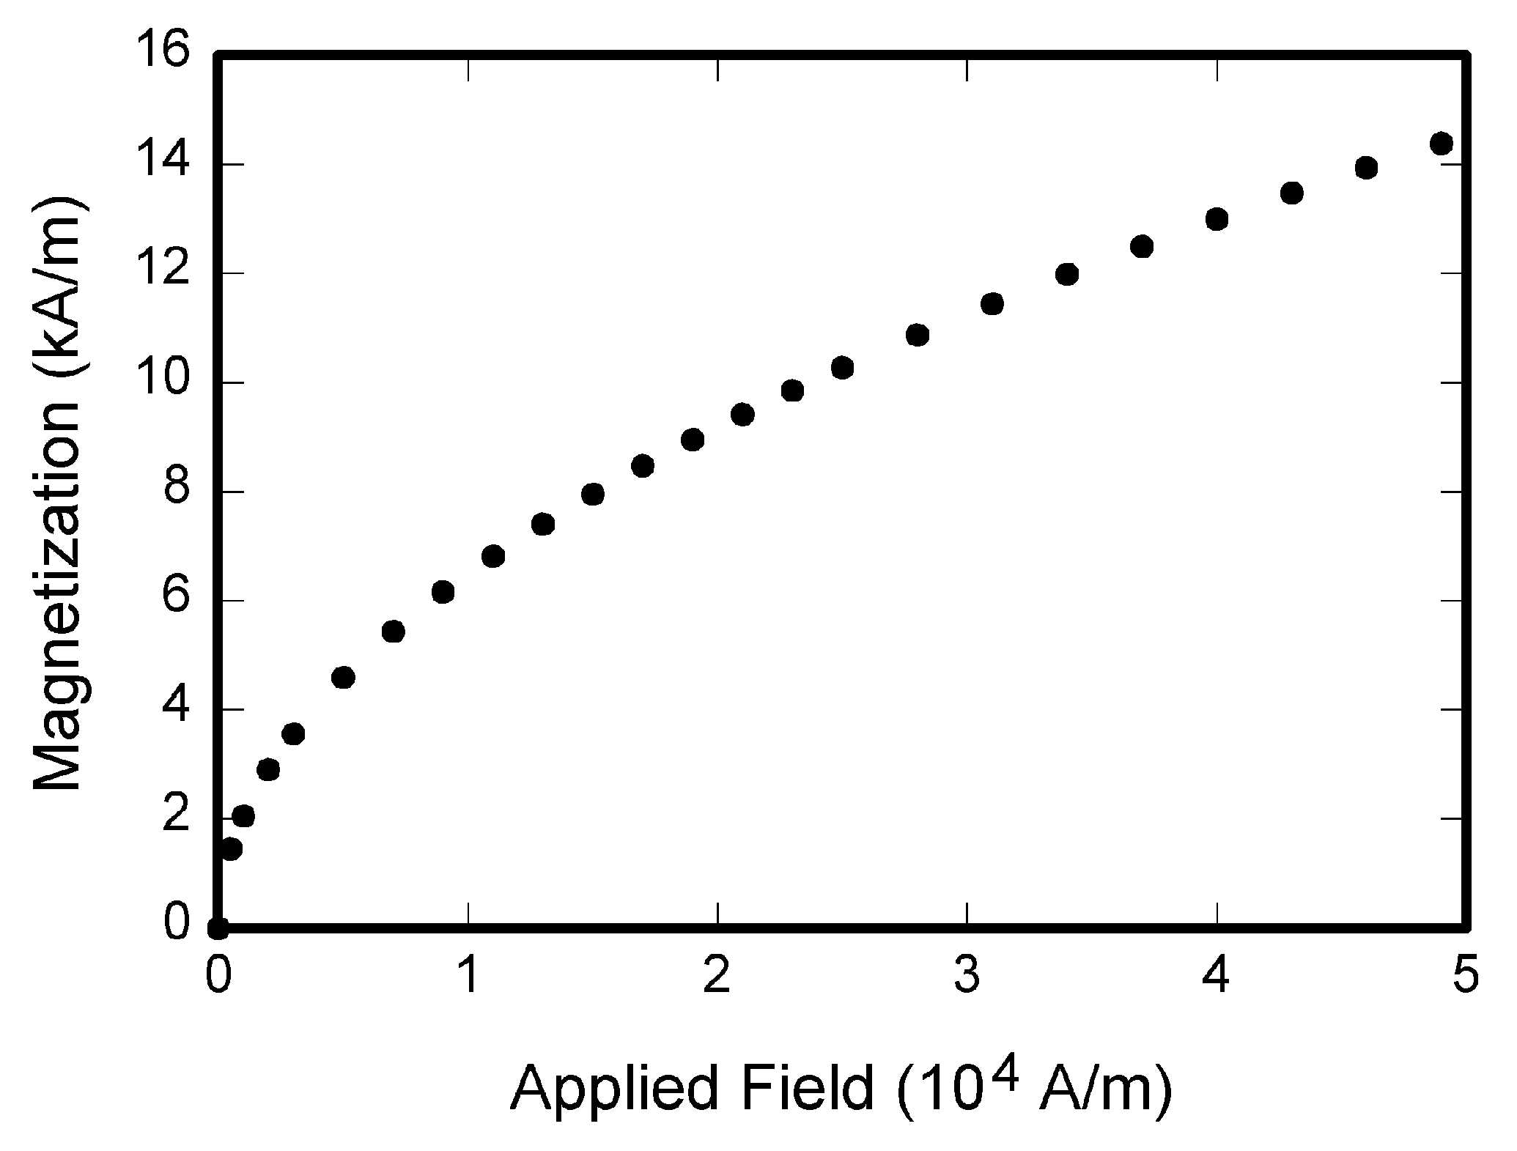
Figure 1.Annotation of this figure.
3.2. Formula
The formulas should be clear and editable. They should be numbered as following:
(1)
(2)
3.2. Table
The tables should be clear and editable. All tables should be numbered by Arabic numbers like Table1, Table 2, Table 3. etc. There should be annotations above each table as following:
Table 1.Annotation of this table
Column1 | Column2
Row1 | Row1
Row2 | Row2
Row3 | Row3
Row4 | Row4
Row5 | Row5
Row6 | Row6
Row7 | Row7
4. Conclusion
This part makes a brief summaryof the whole paper. Usually, there should be one paragraph in this part.
References
There should be at least ten references in the paper. The references should be numbered by [1], [2],[3], etc.
Acknowledgements
Acknowledgements are usually put in the end of the paper, between the reference and the content. There should be no number in this part.

References
- G. Eason, B. Noble, and I. N. Sneddon, “On certain integrals of Lipschitz-Hankel type involving products of Bessel functions,” Phil. Trans. Roy. Soc. London, vol. A247, pp. 529–551
- J. Clerk Maxwell, A Treatise on Electricity and Magnetism, 3rd ed., vol. 2. Oxford: Clarendon, 1892, pp.68–73.
- I. S. Jacobs and C. P. Bean, “Fine particles, thin films and exchange anisotropy,” in Magnetism, vol. III, G. T. Rado and H. Suhl, Eds. New York: Academic, 1963, pp. 271–350.
- K. Elissa, “Title of paper if known,” unpublished.
- R. Nicole, “Title of paper with only first word capitalized,” J. Name Stand. Abbrev.
- Y. Yorozu, M. Hirano, K. Oka, and Y. Tagawa, “Electron spectroscopy studies on magneto-optical media and plastic substrate interface,” IEEE Transl. J. Magn. Japan, vol. 2, pp. 740–741, August 1987 [Digests 9th Annual Conf. Magnetics Japan, p. 301, 1982].
- M. Young, The Technical Writer's Handbook. Mill Valley, CA: University Science, 198.
- Clerk Maxwell, Treatise on Magnetism, 6rd ed., vol. 2. Oxford: Clarendon, 1989, pp.68–73.
- J. Maxwell, A Book on Electricity, 9rd ed., Oxford: Clarendon, 1892, pp.88.
- J. Young, A Technical Write, 5rd ed., vol. 9. Oxford: Clarendon, 2002, pp. 73.

